JOHN MICHAEL FERRARI
Performing Singer Songwriter

- Alt / Country / Pop / Bubblegum / Kid / Standard / Christian
- Unpublished Works: Reverbnation.com/JohnMichaelFerrari
- Previous Album: “My Early Life”
- Website: http://www.johnmichaelferrari.com/

John Michael Ferrari writes emotional story-telling songs with touches of sophistication and/or child-like wonder.

Songs from life experiences; his and others.

Produced by Pepper Jay, Pahrump, Nevada.

one example of many unpublished songs: One Heck of a Girl:
- Sentimental Fool I Keep Dreaming. Undeclared love. Remake of Sentimental Fool (Album: My Early Life).

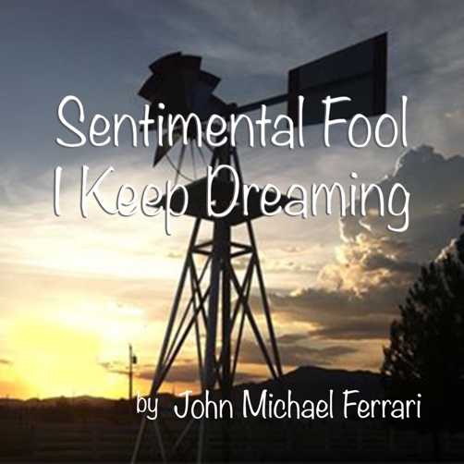

- John Michael Ferrari’s first album, “My Early Life.”

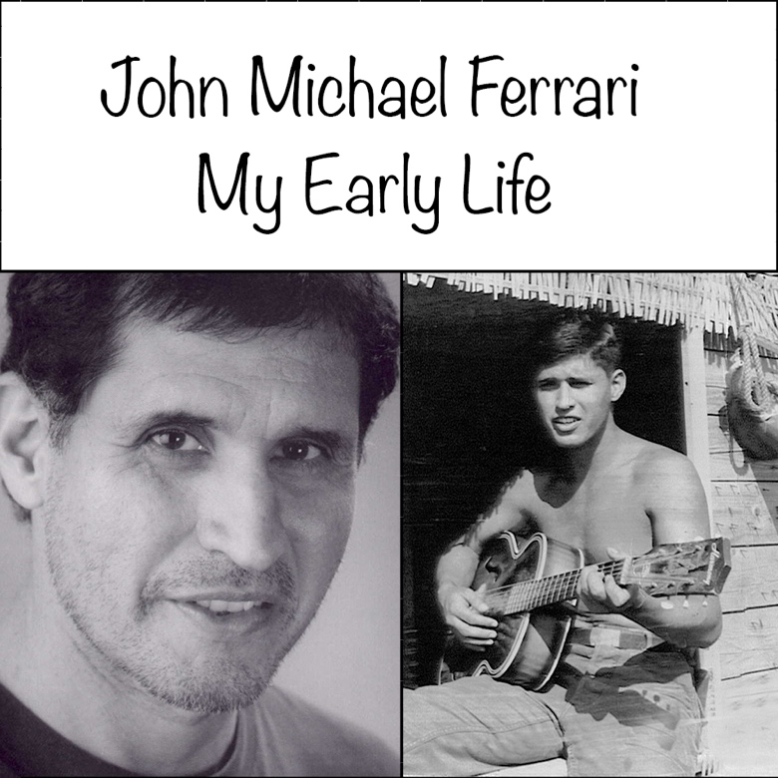

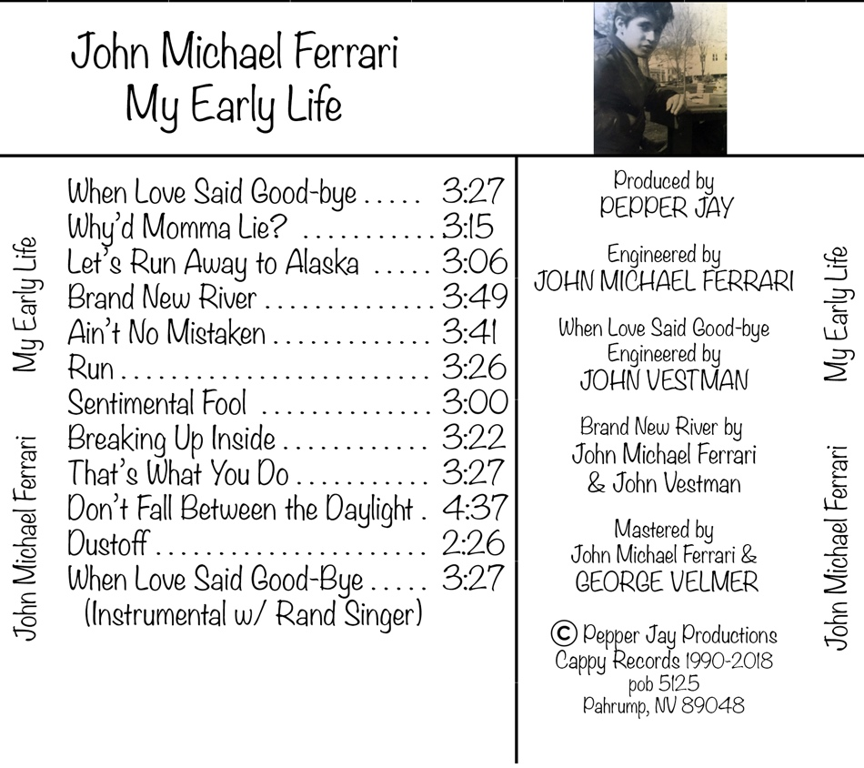

- Some of the 12 cuts on “My Early Life”:

“Let’s Run Away to Alaska,” fun, child-like let’s run away together theme; “tell the animals, the bear and the dear”.

“Why’d Momma Lie?” based loosely on a true store of what happens when love never arrives.

“Don’t Fall Between the Daylight” empathy with teen “cutters.” Prevent suicide. “… and when you’re bleeding, I’m bleeding too.”

“Brand New River” remembering past love, “… then, again, I’m with you.”

“When Love Said Good-bye” moving forward. “I’ll pick up your dreams, put them away, I’ll save mine for another day.”

“Ain’t No Mistaken” no matter how much “we play this game like we just don’t care … “there’s no mistaken, we’ve both been taken with each other.”

“Dustoff” penned by Ferrari in 1966 while serving in the United States Army in Vietnam. Honors the military rescue helicopters and their crews. A favorite among Vietnam War Veterans and the Dustoff Association.

- After a lifetime of performing other people’s songs, John Michael creates entertaining shows and keynote concerts performing his original songs. Whether with the John Michael Ferrari Band or solo/duo performances, audiences feel positively changed and entertained.
- Facebook: John Michael Ferrari Singer Songwriter
https://www.facebook.com/JohnMichaelFerrariSongwriter/

- Trivia: John Michael Ferrari is a teacher and the author of “Acting with Your Eyes” and co-author of "Dynamic Song Performance, The Singer's Bible."

Contact: Pepper Jay, 310-345-9366

Thank you for your consideration,

Pepper Jay

